The Old ground remembered

The approach to the old cricket ground at Fleckney Road was of course virtually identical to that taken to the new ground next to it. As you walked past the working men’s club and began the gentle climb towards the edge of the village the lime trees that lined the road side of the ground would become visible. With their low hanging branches being a perpetual hazard to passing double decker buses they were never popular with the drivers for the old Midland Red company and the minutes of the management committee record regular requests from the council for them to be trimmed.

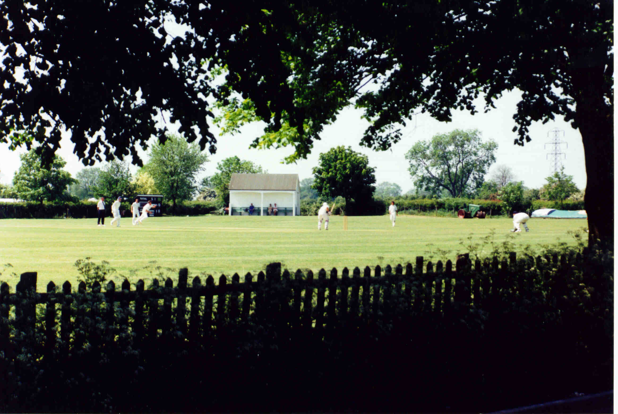
KCC from Fleckney Road

Below the branches you could catch a glimpse of the changing rooms and should your approach be on a winter night you could immediately look to spot whether the outside light was on, indicating that the bar was open, or whether it was off, requiring you to about turn and retreat to “The Swan” for your Friday night pint.
In my head the approach is always in spring with the full promise of a season to come and so as we pass Beauchamp Road and come level with the Fire Station the scene opens out to reveal the newly cut outfield clearly visible through the low chicken wire fence that separates the ground from the drive of the bowls club. In latter years a high net was strung above this fence in an attempt to reduce the number of dented cars suffered by bowls players who parked along the drive at weekends but in my vision the view is unobstructed and I can clearly see a short figure of about five foot three striding backwards and forwards behind a small petrol mower cutting the square.
Lenny Roach was undoubtedly one of the characters of the club when I joined in the late 70’s and remained so for at least the next 15 years. He was the groundsman but also used the club as his own social centre at weekends throughout the year (if the outside light was on in Winter you could bet your bottom dollar that inside would be Len propping up the bar with half a pint of lager in hand.) No one could ever remember Len actually playing cricket, although I once remember him being persuaded to bowl a couple of left arm medium pace deliveries in the nets, but KCC was his social life. His one major fault as a groundsman was that he chain smoked (in my mind he undoubtedly has a ‘fag on’ as he mows) and discarded the dog end’s without a second though wherever he happened to be, whether it be the square, the flower beds or the outfield. For the moment we’ll leave him to his mowing.

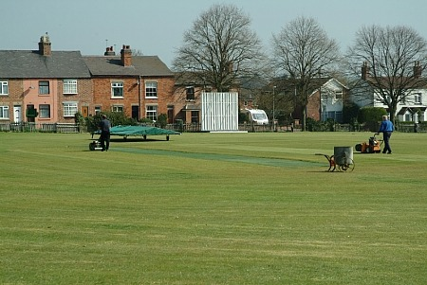
Pre-season work on the square

We are level with the ground now and walking up the path beneath the lime trees. On match days this would be a regular viewing spot for some of the locals, a couple of whom I’m certain never set foot on the ground in their lives but leaned on the low ivy covered fence and watched from the path every week. The fence has a couple of styles in it, useful for fielders scurrying to retrieve the balls from gardens, or half way down Gladstone Street and one of these is directly behind the square. Here there is a gap in the Lime trees giving a viewer an unobstructed panorama of the square.
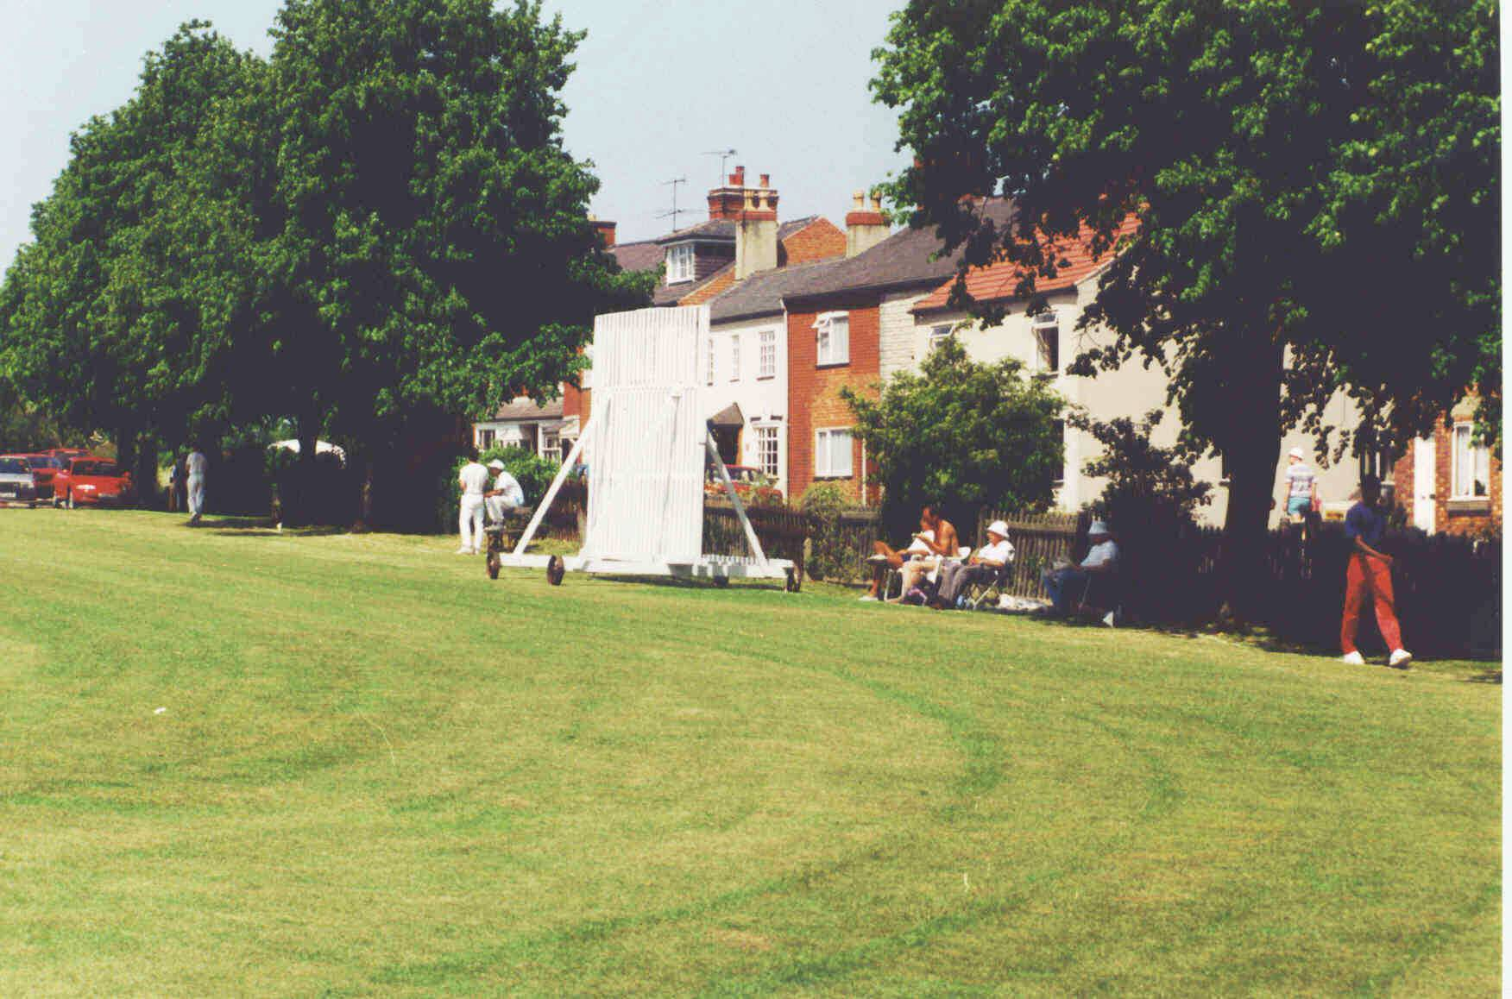
Fleckney Road end

Sadly for those playing on the very top or bottom tracks the gap wasn’t quite big enough and the sightscreen had to be pushed into the tree branches to get it in position, usually with a small shower of leaves and twigs landing on your head. In this gap, just inside the fence is the Kibworth cricket club sign, or two signs, mounted in a V on metal poles so that they can be seen from both directions.

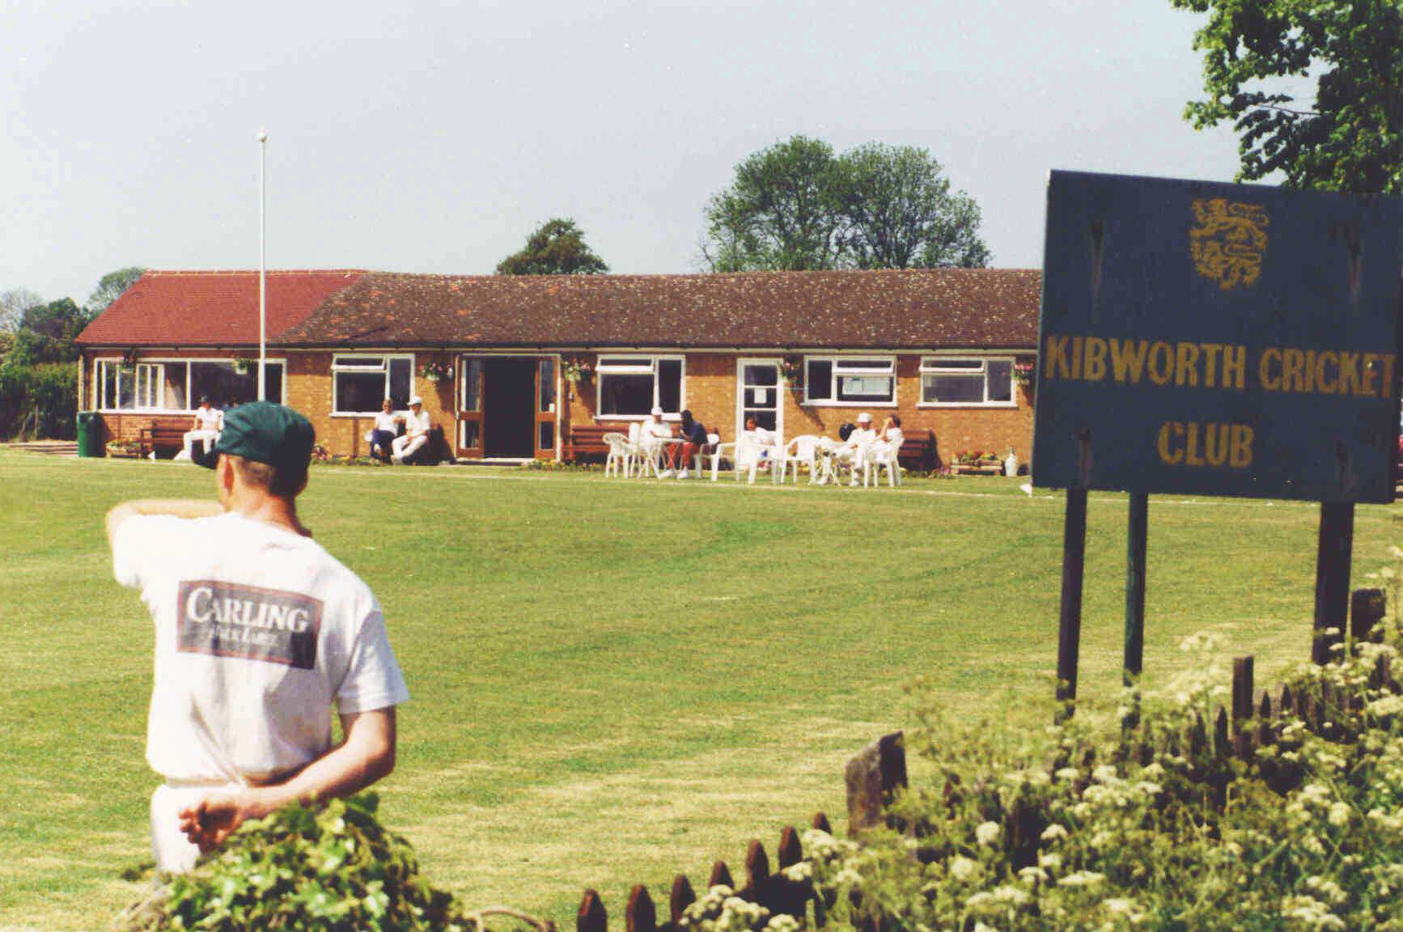
The pavilion viewed from Fleckney Road
The board was repainted some time in the 80’s by another club regular Sam Marriott who was an artist of some repute and redrew what had been two fairly scraggy lions as much more magnificent animals.
If we take a moment to stand here, behind the bowlers arm from the Fleckney Road end we can see the full ground laid out in front of us.
The bowls club lies to the left, its drive way running half the length of the boundary, then the single storey pavilion and beyond that a low picket fence which marks the side of the green itself. Several high metal poles rise from the fence to support the netting which hopefully catches any balls struck in that direction. The far side of the ground, backing onto Michael Vickers field has a six foot hedge running along it with several mature trees and directly opposite us a small style allowing access to the field for ball collection. For several years the nets were placed along this hedge roughly where the original pavilion stood before an artificial wicket was added to the top end of the square and a portable cage was made allowing practice to take place on it.
The original pavilion had gone a decade before I first came to the club but was fondly remembered, although its limitations were widely recognized. There were two changing rooms either side of the main ‘pavilion room’ which looked out onto the ground and was where players, members and visitors would sit in inclement weather, and post match socializing and drinks. The bar was adjacent to the home changing room. There was no water on tap at the pavilion so it had to be carried the full length of the field from the tea room to both changing rooms and for washing glasses.

As we reach the right hand corner of the ground we can see the scorebox, added in 1982, and behind it the ‘Bolton Oak’ planted in 1979 after the death of long serving player and administrator Stan Bolton. It is one of the few sadness’s of the ground move is that symbols such as the Bolton Oak, no doubt intended to stand looking over the ground for many years ended up being grubbed out by a David Wilson digger after only a quarter of a century.

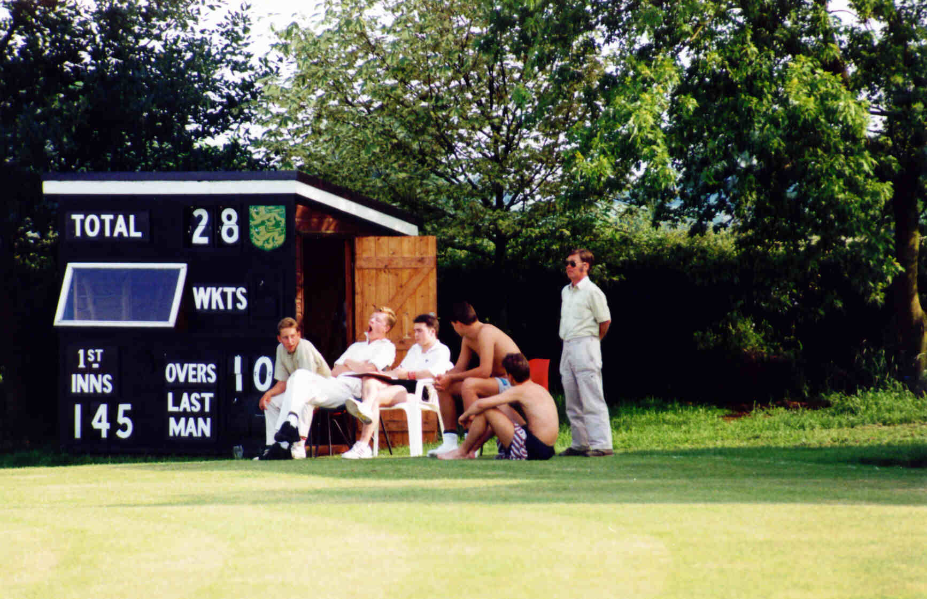
The scorebox, Len roach stands to the right of the group

The scorebox itself needs no description, it still stands over looking the second ground at the new KCC but to its right stood a far more substantial structure, the equipment shed.
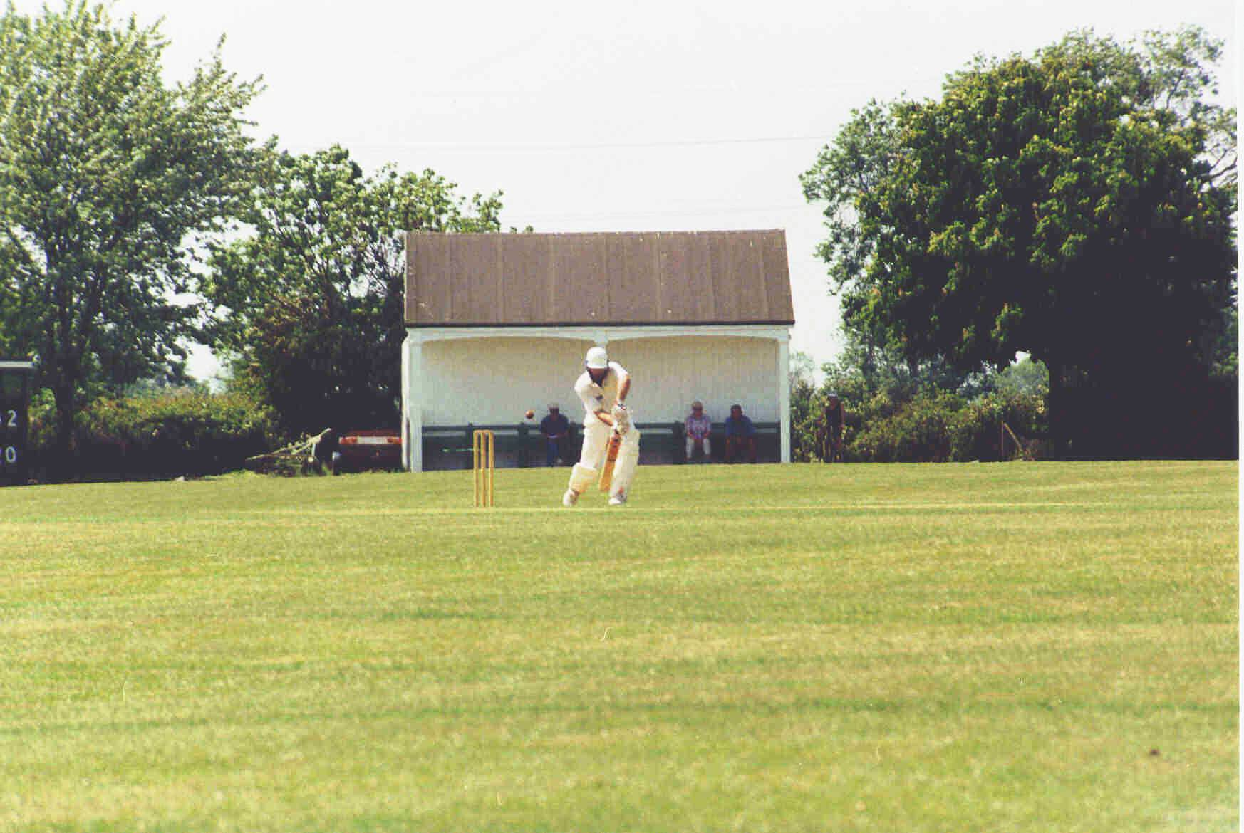
The equipment shed

Built using wood from the original pavilion it had a pitched roof and big double doors at either end so that large pieces of equipment such as the roller and tractor could be driven straight in. One the front a bench seat had been placed which was widely known as ‘critic’s corner’. This was a favourite haunt of a group of ‘senior’ members, some of them former players who would comment vocally on the performances laid out in front of them. This seems to have been the continuation of an age old tradition as apparently in the days of the original pavilion there was a small equipment shed, housing the motor roller, situated along the westward boundary. A wooden bench was joined to this shed and a little old man, whose name no-one could remember, would sit there for almost every match rattling his stick against the side of the shed if he thought the scoring rate was too slow. The reasons for the newer version of ‘critics corner’ being so popular were obvious, it was under cover, shady and close enough to the scorebox for them to bark out regular requests to the scorers for information on batsmen’s scores and various other bits of information that would test the capabilities of a Bill Frindall. The other point about this position was that the ground was not flat and sloped away front the shed at a noticeable angle so that the watcher got a slightly elevated view of play. The equipment shed was badly damaged in a fire in the 1980’s the causes of which were never fully identified but had something to do with a tractor battery being left on charge. Although the front was repainted the back and sides showed the charring for the rest of their days.
The back of the shed was for many years a wasteland of weeds, grass cuttings and old tyres until the decision was made to lease part of Michael Vickers field behind the ground for a car park and net area. The gap between the equipment shed and the hedge bordering what would become the new ground became the entrance to this car park which meant no more need to park your vehicle in the target gallery that was the previous parking area. This had been the gravel strip running along the length of boundary between equipment shed and pavilion. It was shale covered and for several seasons when I joined one of the end of season tasks would be to weed it until someone realized that this was a senseless task and allowed the grass to grow unhindered. With the advent of the new car park this area became the storage space for the covers and net cage.
Finally as our gaze reached the right hand corner of the ground we see the single storey pavilion with flower beds in front and a small car park area, marked off with low white posts and a plastic chain slung between them. To the left of the pavilion is a wooden shed used to store garden furniture and between that and the pavilion is the style that allowed access to Eddie Welton’s favorite cow field, now our new home.

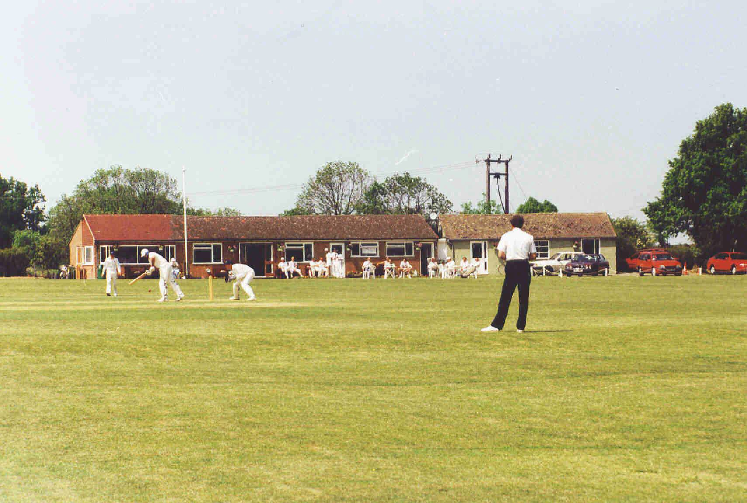
The Pavilion

The pavilion itself is an unimpressive structure with a hotchpotch of different coloured tiles on an uneven roof, the result of various repairs after the impact of sixes. The pavilion is obviously in two parts, the right hand which is now the changing rooms being originally a free standing tea room before the remainder to the structure was built in the late 1960’s. The two halves are joined by what was originally the store for beer barrels and later became a cricket kit store and the world’s smallest umpires changing room.

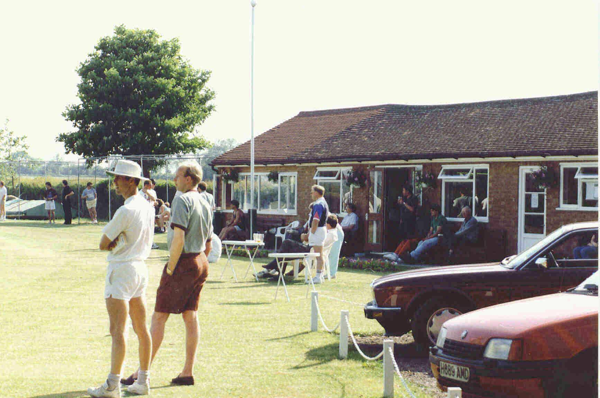
The Pavilion & car park

Let’s walk up to the pavilion along Fleckney Road under the shade of the second set of Lime trees. One of this group is significantly smaller than its companions and would always come into leaf and drop those leaves later than the rest because, or so Len Roach would regularly remind you, it marked the position of the original gate into the ground. We have now reached the current gate; a green metal affair which is has been pegged back against the small brick meter house next to the first lime tree. The small car park in front of the pavilion, able to hold no more than four or five vehicles, is empty and we can hop over the low chain fence onto the field. The first thing that is obvious as we walk towards the square is that field is nowhere near flat, there are three definite steps to it, with the square making up the second of these. The change from the top tier by the pavilion to the square is gentle and we can walk down onto the square.

The artificial wicket is nearest the pavilion and if we turn to look back its easy to understand the state of the roof as the boundary is no more than 40 yards. By the turn of the century it was a brave man indeed that would leave a car parked either in front of the pavilion or along the boundary as even miss hits could easily clear the white line and smash into door panels. The same problem also exists with the straight boundary to the road which was a similar distance away. The lime trees could stop many shots but the danger to passing cars and householders was real and every present. This is particularly true for the houses on the corner of Fleckney Road and Gladstone Street where there is the gap in the Limes. One of the owners unwisely decided to put Georgian style windows into the front of their house, maybe thinking that small panes of glass would be cheaper to replace than large. From memory it took Dave Collins, one of the clubs most consistent straight hitters about six weeks to hit this window precisely on one of the wooden cross pieces in this window so that four panes were shattered simultaneously. The house next door to this was for the last few years of the grounds existence owned by one of the players and there was a standing prize, sadly never claimed, for anyone who could hit his satellite dish. Such was the closeness of these properties that they were occasionally cleared completely, thereby threatening the residents even as they sat in their back gardens. The biggest hit I ever saw (In the 1984 centenary game) by Australian Mike Haysman, was still on the way up as it rocketed about 15 feet over the roofs. Len Roach would claim to have seen an even longer strike by one of the clubs famed big hitters of the 1940’s, a rotund gent named Cis Berry, who apparently one top edged a hook which cleared the Lime trees to bounce on the roof of the knitwear factory that used to stand on the corner of Dover Street some 100 plus yards away.

The square is virtually flat, thanks to some 1940’s earth moving, but small. There are only around nine separate tracks and to maximize the number of available wickets Len would often move half a track down to give 18 possible combinations. As we reach the bottom end of the square we can see that from the last couple of tracks the bowls club is now just a chip shot away and the reasons for all the netting becomes clear. In spite of this protection there always remained the risk of either clearing the net or missing it to the side and still managing to hit the green. On one occasion I managed to hit a six onto the roof of the bowls pavilion (from the bottom track obviously) which bounced down onto the slabs that surrounded the green then took one final hop to hit an unfortunate player from behind just as he bent forward to bowl. The ball caught him smack in the unmentionables and he collapsed in a heap causing us to think for a few seconds that we might have killed him. Luckily the offers of help from several of the lady players seemed to perk him up and he was able to continue. We actually got the ball back from that incident, which wasn’t always the case as relations could sometimes become frayed. The bowlers used to become particularly upset when the ball landed on the green on days that the club was locked up. One of the more nimble players could easily scale the wooden fence, with the help of a wheelie bin and unfortunately the marks of a set of cricket spikes across the middle of the green greeted the groundsman on more than one occasion. Looking towards the bowls club it comes obvious that there is a noticeable ridge in the outfield running parallel to the pitches about 10 yards from the end of the square. This marks the end of the square leveling and the start of the drop off to the boundary fence that makes up the third and final level of the ground. More than once a fielder back peddling to take a catch could be caught out by this ridge and find himself tumbling over whilst the ball smacked into the turf some yards away.

It looks like Len has finished his mowing and, having left just a couple of fag ends on the wicket, taken the mower up to the equipment shed. A rumble and a cloud of black exhaust fumes announced that he has started up the roller and is about the reverse this out and drive down to the square. The old KCC roller was a huge machine, an old green road roller complete with cab that was almost certainly far too heavy for the job. It may well explain why the pitches at Kibworth were always more likely to threaten the batsmen ankles than their chins. The maintenance of the roller was one of the special tasks that only Ron Beet could manage. Not only was Ron one of the clubs greatest servants as a bowler but he was also the maintenance man, often to be seen in his green, one piece overalls working away on some piece of equipment. On one occasion when the roller ran out of diesel near the square, with Ron not available to achieve the special trick of getting the air out of the fuel pipe to restart it, a junior game had to be played with the roller fielding at mid on. All appears well this evening however and as Len trundles down the slope from the equipment shed at a fair old pace we beat a wise retreat to the pavilion for a beer.

As it’s spring Malcolm Scranage has yet to fill up the flower beds in front of the pavilion or put up the hanging baskets that will adorn the eaves (except on the day that following a friendly game the Lancaster University students decided to take them as trophies). To see Malcolm picking Len’s fag ends from between his blooms was always a cause for much chuckling between those watching.

We will start in the changing rooms at the right hand end, the old tea room now converted to provide ‘Home’ changing to the left and ‘away’ to the right with a large shower area separating the two. This central part was disproportionately big taking up more than a third of the entire changing area and during the 1990’s a redesign would see most of this space added to each of the changing rooms with only a narrow shower area running along the back wall. This change was badly needed as the original ‘away’ changing room in particular was tiny and woefully inadequate once the cricket ’coffin’ become a regular item. Even the redesign left people stumbling over equipment as they attempted to make their way in and out. We will ignore the former barstore that joins the ‘home’ changing room to the kitchen and step outside to look at the clock mounted on top of it. This clock hides the two grey plastic cold water tanks that service the showers and is topped by a copy of the Lord’s ‘Old father Time’ weather vane.

A single door allows us to pop our head into the kitchen area, a white painted room with very basic cupboards and a small domestic oven. It served well as a place to prepare teas but was totally inadequate for anything grander. There is no-one at home so we decide to walk to our left along the path towards the double doors that will provide access to the bar. On our way we pass one further single door, rarely used that would give us access to the toilets without going through the bar. Both the main doors are open so we walk-in and stand on the threshold. The main bar area forms a rectangle and as our visit is in the early 1980’s the bar stands in the right hand corner although it will shortly be moved to the left hand side with a new bar store being constructed behind it. The bar is a small wood paneled affair with room for four beer taps on the front and two more on the right hand side where there is also a small hatch allowing people to get in and out.

When I joined there were just three beer taps, one for Harp Lager, one for Youngers Tartan Bitter and a third for Tartan Mild (which almost no-one drank). A fourth tap was soon added at Len Roach’s insistence to provide his favourite tipple …..Lowenbrau Lager. Beer barrels had to be rolled from the barstore through the kitchen and all the way past the bar to access the hatch and nobody was sorry to see this job go with the bar move. To the right of the bar area is another smaller rectangular area leading to the kitchen and access to both ladies and gents toilets is off this area. The rectangular space will later be used as the space for placing the clubs TV and then the site for a pool table but for the moment it is just an extension of the bar area with the same tables and chairs as are dotted around the rest of the room. What tables and chairs they are too!! More suited to a works canteen than a social venue….red plastic stacking chairs and metal legged, sky blue laminated square tables. The other thing that makes the place seem less than welcoming are the cheap brown carpet tiles that cover the floor, even these apparently went down only because an attempt to paint the ceiling put more paint on the laminated floor than it did on the ceiling. By the way that’s purple paint!!

Entering the room we turn to our right and notice that there is a large window next to the door and another in the side wall of the pavilion looking up the car park towards the equipment shed. In front of the window that faces out onto the ground is a rectangular table with a yellow laminated top, you can still see it today in the scorebox that looks over the second ground. Then as now it is there for the scorers complete with a small black switch pad that operates the light in the corner of the window for signaling to the umpires. The scoreboard itself is on the wall between the double doors and the window and the ‘tins’ carrying the numbers sit in a wooden box under the table ready for use at the weekend.

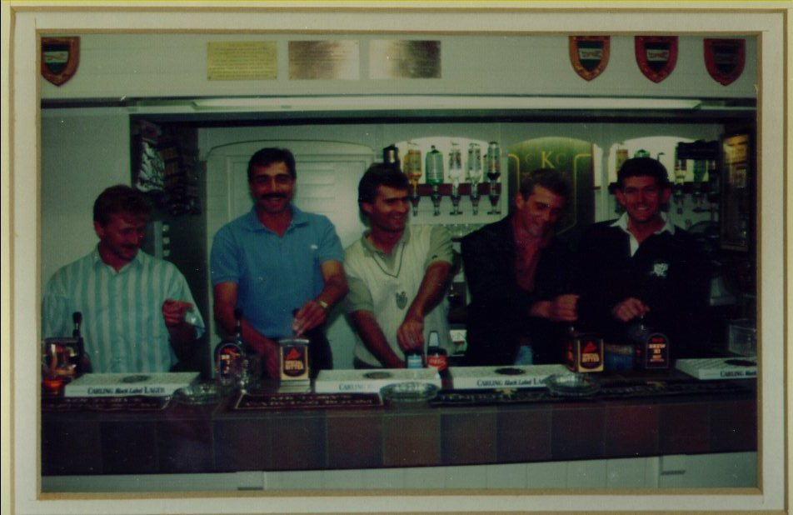
Opening of the new bar 1989

The 1980’s revamp certainly improved this rather dingy scene by not only siting the bar in the wall on the right hand side, next to the window looking up the car park but also introducing some padding bench seating along the walls, new chairs and tables and also a magnificent copy of the club logo on the back wall (thanks to Sam Marriott again). One other new development was less successful however as the area the other side of the side window, which now backed onto the new bar & storeroom, was made an outdoor seating area. Rarely used it was covered over within a few years and the window and wall removed to make an indoor seating area with panorama window. It was designated as a non-smoking lounge until smoking anywhere in the pavilion was finally banned.

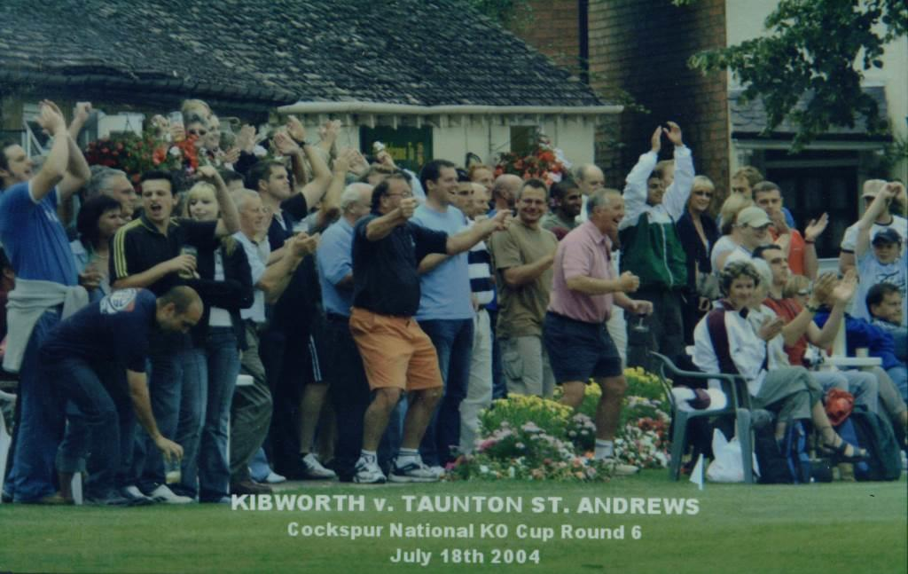

Malc Scranage’s flower beds are clearly visible at the front and the changing rooms (painted white) can be seen behind as the crowd celebrates victory.

